INSTRUCTIONS FOR WRAPPING BOXES WITH HONEY
The following visual directions apply to wrapping all boxes that contain any honey. Boxes with honey that are not wrapped cannot be accepted as they may drip during processing and contaminate the irradiation processing facility.
STEP 1: for each box you will need 1 heavy duty trash bag, duct tape, permanent marker.
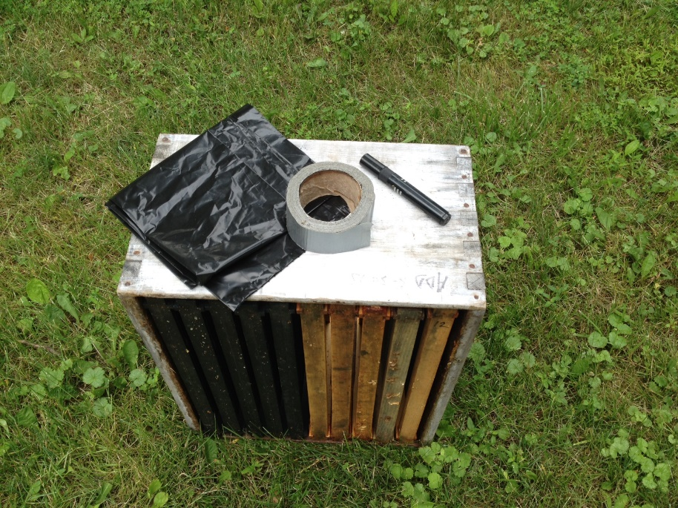

STEP 2: Open the trash bag and cover the box from the narrow end sleeveing it down.
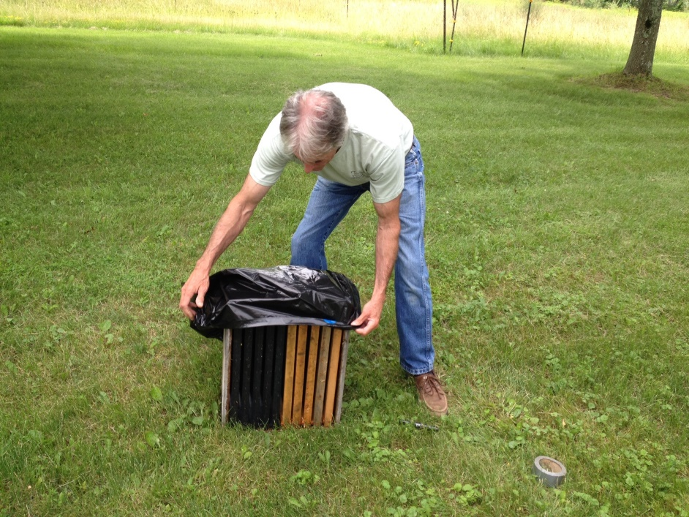

STEP 3: Being careful not to tear the bag, turn the box over to expose the open end of the bag. Close the bag by first folding in the edge along the long bottom edge, second the sides and third the top, taping as you go!
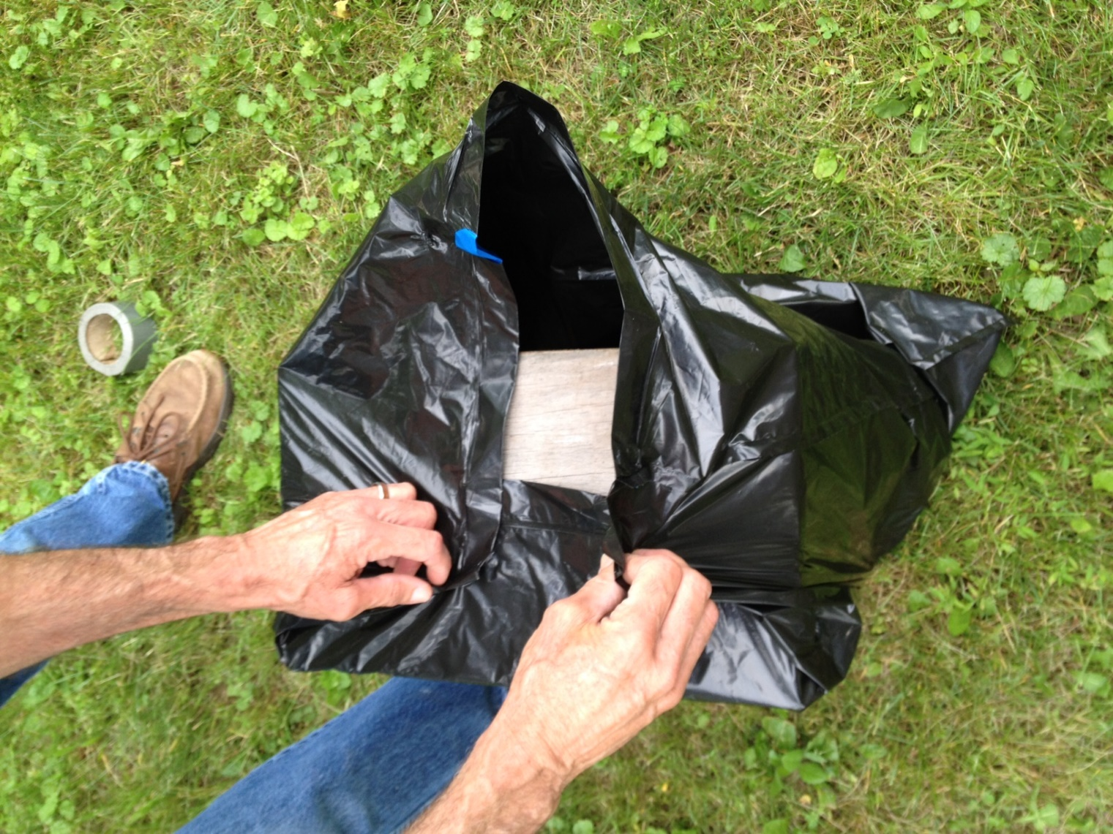

STEP 4: Tape each edge of the bag as you close it, taping it to the box. Here the bottom edge and the sides are being taped. Continue until the top edge is sealed over the other edges, completely covering the box. Ensure that all gaps are taped closed to avoid any honey leaking from the bag.
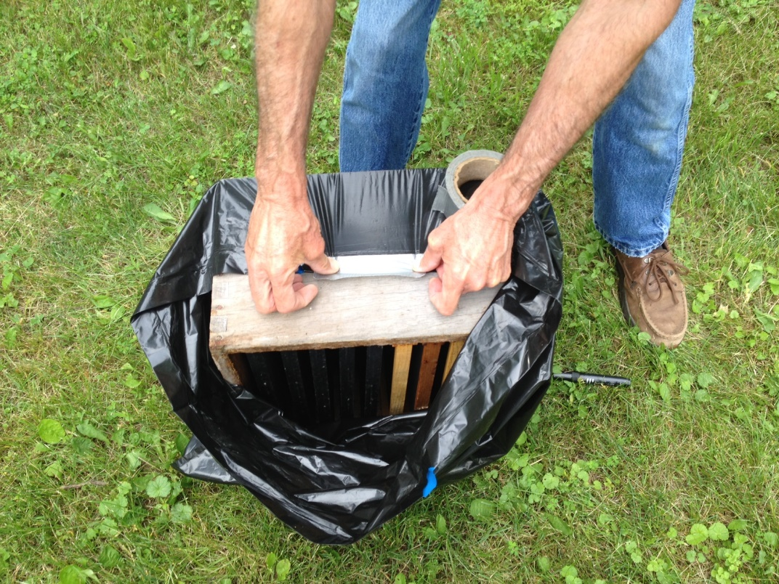
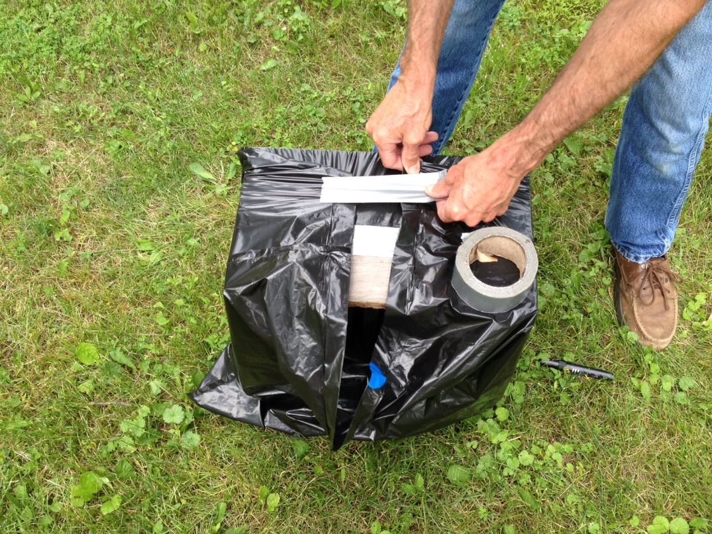
STEP 5: Use the permanent marker to write your Name and Phone Number on the Package. You may write it on the exposed tape, or apply a paper label. Every box should be labeled.

