Making a house for native bees
MATERIALS TO MAKE 2 HOUSES:
1 8ft 1”x4” board (furring strips – the cheapest lumber available should suffice).
16 #6x1-1/2 in flat Phillips screws.
Phragmites stems about 3/16 to 3/8 inch inside diameter, cut 10-.5 inches long with one end closed at the node. Lovage, Poke, Japanese Knot weed, or other hollow stem plants also work. Plastic drinking straws do not work well because they do not “breathe”.
(Mason bees will use tubes of about 5/16 inch inside diameter (about the size to take a #2 pencil). Leaf cutters seem to prefer 3/16 in tubes, but many other native pollinators use other diameters, so a variety of sizes is good.)
2 squares of hardware cloth, 8inches on a side with 1/2in x 1/2in mesh size.
2 shelf or corner brackets with screws (for mounting box outdoors).
PROCEDURE:
1: Cut 8 pieces from the board, each 10.75in long.
2: At step 7, cut 2 pieces of board, 5in long to cover the Back of the box.
3: Predrill holes for screws as follows: (Recommend inserting each screw partially to keep its holes aligned before drilling for the next screw.)
4: Assemble 2 long pieces, edge to edge, at right angles, using a screw located ~1-2 inches from each end.
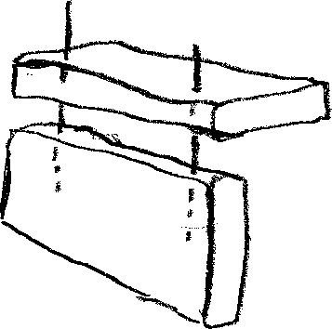
5: Make 4 of these pairs.
6: Fit 2 pairs together to make a rectangular, open ended box, using 1 screw in the center of the connecting boards on each side. Do the same with the other 2 pairs to make a second box.
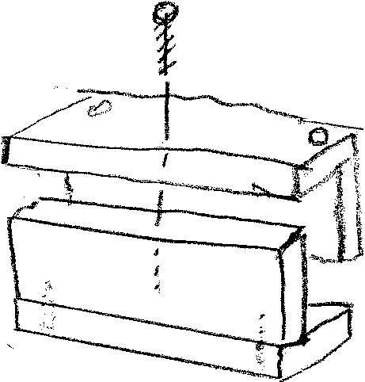
7.One of the small remaining pieces should fit over one open end as a back. Attach with one screw on each side. (These screws go into the end grain of the box, so they should not be relied on to take the weight of the box when mounting it.)
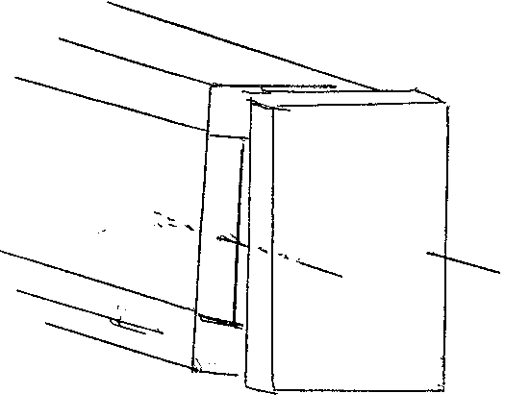
8: Use local clay mud to seal any open edges in the back or sides of the house.
9: Cut the hardware cloth in a square that covers the end of the box at a 45 degree angle. (Use the actual box as a template for size.)
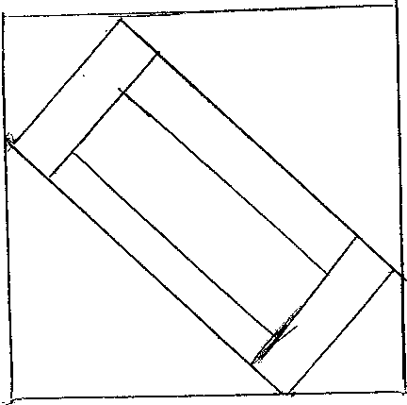
10: Fold the corners of the hardware cloth square up so that the remaining flat rectangle is the same dimensions as the end of the box. Crease the folds sharply. This cage should fit snuggly over the outside of the open end and extend about an inch beyond the opening of the box. (This will serve to keep the birds from destroying the open ends of the tubes, or from pulling the tubes out of the box)
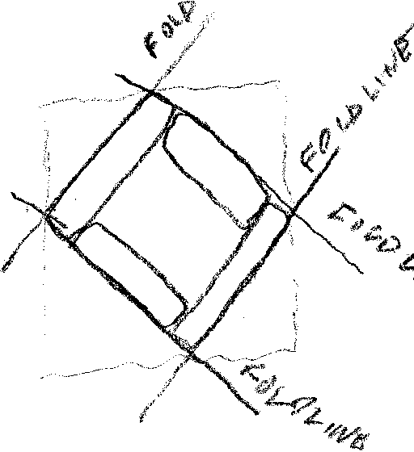
11: Before installing the wire cover, slide the Phrag tubes into the box. The closed node end should be against the closed end of the box and the open end should be slightly recessed in from the open end of the box. Put enough tubes into each box to fit tightly, and not fall out or shift if the box is upturned. Be sure they fit tightly so they don’t move around, as that will confuse the mothers. When the tubes are in and tight, attach the bird guard screen over the open end of the box with a friction fit.
MOUNTING & ENVIRONMENT:
The opening of the box should face South or SE and be at least 4ft above the ground (so you can see the residents, but ground dwelling raccoons can’t get into it easily).It can be higher ie under the eaves of a shed. The open end of the box should tilt very slightly downward to allow rain to drain out.
Mason bees need a source of wet mud nearby (not right under the house!) If you dig a shallow hole about 1-2ft in diameter and about 6 inches deep in bare earth (not mulch) and pour a bucket of water into the hole at least once a day, the local clay should stay wet enough for the bees to dig and carry. Use that mud to seal the back board to the house and any obvious voids along the side boards. Leaf cutter bees will cut tiny circles from rose or lilac leaves or any other thin smooth leaves nearby. This will not hurt the plants and will tell you the leaf cutters have arrived.
Use the bracket to screw the box into a secure position with the face in correct orientation for morning sun. The box should not swing.
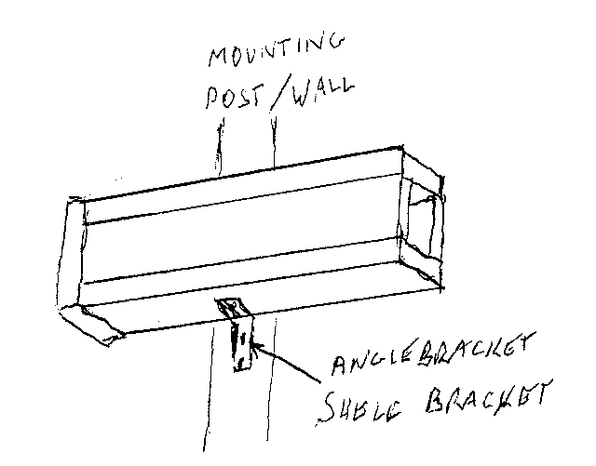
Try not to move the box until late fall.
Try to get the houses in position by mid-March or when temperatures are at least 50 degrees much of the daytime. Mason bees are active when any fruit trees begin to bloom. Leaf cutter bees will be active when night temps are in the 50s and daytimes are around 70F or more. Plant more flowering annuals, perennials, shrubs( like Chaste Tree, Aronia, Abelia), and trees to encourage native pollinators. Avoid special cultivars and double blossoms because their focus is on color rather than scent or nectar. Choose simple “daisy like” or tubular flowers. Think apple blossoms, purple cone flowers, zinnia, bee balm for a start. Agastache “Blue Fortune” is an exception because this cultivar was bred for pollinators and is extremely effective!
WINTER CARE:
After the first killing frost, bring the bee boxes into an unheated shed or garage where they can be protected from precipitation and mice. Outdoors, birds and other foragers will work hard to open the tubes or pull them out of the box and frequent rain or snow will keep the box damp and encourage mold and rot. Periods of unseasonable warmth will force the encased bees to use stored food reserves and may even result in premature hatching. A basement is probably not cold enough, but the cocoons should not freeze!
An alternative is to split the tubes open, extract the cocoons and sift them with sand to remove frass and mud, then place them into a plastic container in the refrigerator for the winter. The container should have two or three small holes for minimum ventilation and a slightly damp paper towel. Check every few weeks to be sure that the towel remains just slightly damp.If the cocoons are a bit moldy, don’t worry, but remove the paper towel and keep the interior of the container a bit drier. Label the container on several sides to avoid unexpected surprises for the human browsers in your refrigerator!

PREPARE FOR SPRING:
In early to mid March, prepare to remount the boxes outdoors. If you stored tubes separately , now is the time to replace the tubes in the boxes so that they are snug. Using the diameters of the tubes that bees chose last year, try to add new empty tubes of the same diameter to provide appropriate homes for the new bees who hatch. If you stored the cocoons in the refrigerator, leave about ¼ inch of space in the box when you replace tubes. Be careful when handling because the tubes are more likely to fall out. Divide up the cocoons you stored and pour equal portions of cocoons into that little space in the boxes. When the bees emerge they will find their way out. By mid July you can insert new tubes to fill the box tightly.

